Safe Operating Procedure – Receipt and Despatch of Loan Kits

Description of Task | PACKING AND UNPACKING SURGICAL LOAN SET TRANSPORT CASES
Identified Risk | Musculoskeletal Disorder – Shoulder, neck, upper limb and lower back strain
Safety Controls | - Mechanical lifting device must be used at all times  - Training – in SOPs for the safe use of mechanical aids.  - Prepare workstations and surrounds, e.g.: How and where it arrives and leaves.
Precautions to be exercised | - Consider body positioning while sliding trays in and out of the transport cases – minimise twisting and turning  - Recommended tray weight of 5-7kgs (for trays over this weight, decant )  - Lifting device to be connected to AC outlet for recharging daily.
Training and Competency | - Completion of competency-based manual handling training re SOPs; equipment; etc. Address individual needs where applicable  - Ongoing workplace assessment by M/H Co-ordinator and/or nominated competent person
Supervision | - Implementation of buddy system  - Ongoing workplace supervision by M/H Co-ordinator and/or nominated competent person
Relevant Legislation and Standards | - NSW – Work Health and Safety Act 2011  - NSW - Work Health and Safety Regulation 2011  - Code of Practice – Hazardous Manual Tasks  - National Guide for the Safe Design and Handling of Surgical Instrument Transport Cases (2011)
Information and Resources | - Health Service Organisation [HSO]  - Orientation  - Team Meetings  - Safe Operating Procedure/s [SOP] must be displayed in appropriate area/s.

Safe Operating Procedure – RECEIPT OF LOAN KITS

TASK: UNPACKING LOAN SURGICAL INSTRUMENT SETS FROM NEW TRANSPORT CASES

- Prior to commencing task, complete Health and Safety checklist for work environment, refer to pre-start checklists

- Instruct courier to deliver stacked loan kit/s on wheeled platform/s to designated receipt area that contains:  - Appropriate lifting device (fixed / mobile) | 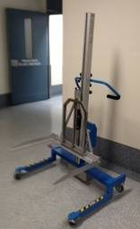
- Adjustable workstation with roller/s positioned facing lifting device | 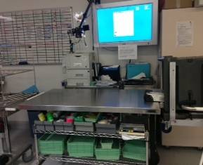
- Delivery receipt documented as per hospital policy | 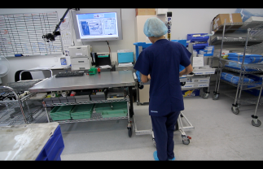
- Wheel stacked loan kits to unpacking / processing area and onto fixed or mobile lifter (located beside adjustable workbench).

- Ensure brakes are applied (if mobile lifter) | 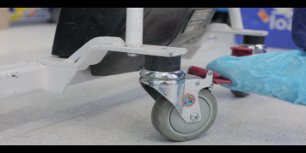
- Ensure case/s are secured onto the wheeled platform (dolly). | 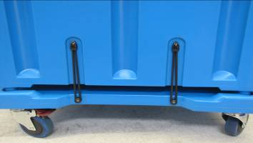

TASK: UNPACKING LOAN SURGICAL INSTRUMENT SETS FROM NEW TRANSPORT CASES
continued
- Open door of transport case/s and secure into ‘open’ position using stretch loop. | 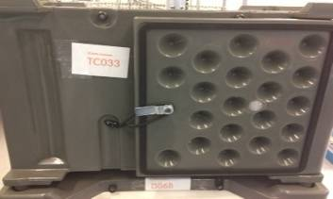
- Raise / lower lifting device so that the instrument tray (to be unloaded from transport case) is at workstation height | 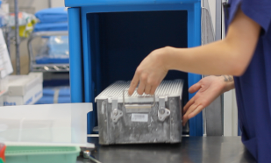
- Slide instrument tray from transport case onto workstation. Decant as necessary. Check instrument tray against original order (following QA procedures)

- Identify instrument tray as per HSO protocols for reprocessing | 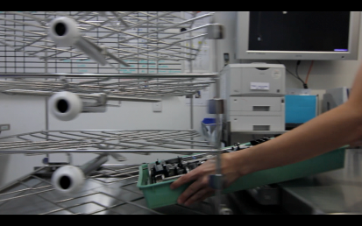
- Using workstation rollers, transfer instrument trays and required instruments onto washer disinfector trolley (or equivalent) for transfer to cleaning process.

- Using lifting device, adjust height of transport case to remove the next instrument tray. | 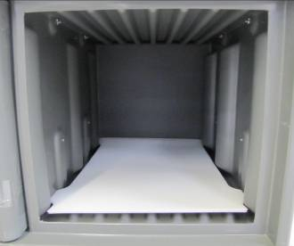
- Repeat process for each instrument tray until transport case is empty.
*slip sheets to remain in transport case– do not remove during unpacking process.
Return outer trays to container.
Identify transport case for packing and despatch

- Transfer empty transport case/s to designated holding area. Remove any unnecessary labelling and stack containers for storage using your risk assessment protocols | 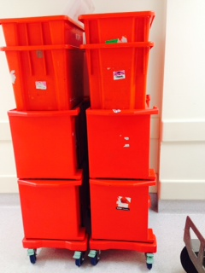

Safe Operating Procedure – DESPATCH OF LOAN KITS

TASK: PACKING LOAN SURGICAL INSTRUMENT SETS INTO NEW TRANSPORT CASES FOR DESPATCH
- Prior to commencing task, complete Health and Safety checklist for work environment; refer to pre-start checklists

- Transport case/s on their wheeled platform (dolly) from designated holding area to loan set area
- Securely position the mechanical lifter under the road case’s wheeled platform

- Using lifter, raise the container

- Unlock door and secure door in open position, align mechanical lifter to the workstation and ensure brakes are applied (if mobile lifter)
- Once terminal process has taken place, wheel instrument trays on mobile trolley/ to loan set area. Transfer each tray with instruments onto workbench (with roller/s).

- Check out instrument trays as per HSO policy and manufacturer’s instructions

- Ensure each lid is secured onto tray

- Ensure heaviest trays are positioned lowest in case (and heaviest cases are positioned lowest in stack)

- Leaving one slip-sheet at the base, remove extra slip sheets from transport case to workstation.

- Slide first tray into transport case, via rollers.

- Use lifter to raise / lower cases so that individual trays are loaded at workbench height.

TASK: PACKING LOAN SURGICAL INSTRUMENT SETS INTO NEW TRANSPORT CASES FOR DESPATCH continued
- Slide and position the next slip sheet on top of that tray in the transport case.

- Repeat process until transport case is full.
(Any un-used slide sheets can be re-positioned above the top tray inside the transport case)

- Enclose all relevant documentation as per HSO policy.

- Securely lock and label each case

- Using mechanical lifter, collect pre-packed prosthesis tubs and place on top of wheeled container ready for collection (see picture below)

- Wheel transport cases to be picked up by courier in the designated despatch area

- Complete despatch documentation as per HSO policy



